( 1 ) ***T(6th Sm.)-Botany-H/CC-14/CBCS***

# 2021

**BOTANY — HONOURS**

**Paper : CC-14**

**Full Marks : 50**

*The figures in the margin indicate full marks.*

*Candidates are required to give their answers in their own words as far as practicable.*

1. Answer the following questions (***any five***): 2×5
   1. Where does substrate level phosphorylation occur in glycolysis?

**Substrate level phosphorylation** occurs in glycolysis at two specific steps:

**Step 3:** When glyceraldehyde 3-phosphate (G3P) is converted to dihydroxyacetone phosphate (DHAP) by the enzyme glyceraldehyde-3-phosphate dehydrogenase.

**Step 10:** When phosphoenolpyruvate (PEP) is converted to pyruvate by pyruvate kinase.

* 1. What is ‘Quantasome’? Write the chemical formula of chlorophyll a.

A **quantasome** is a complex of proteins and pigments (like chlorophyll) within the thylakoid membrane of chloroplasts. They are the functional units where light is absorbed during photosynthesis.

Chlorophyll a has the chemical formula **C₅₅H₇₂MgN₄O₅**.

* 1. What is ‘uncoupler’? Cite one example.

An uncoupler is a molecule that disrupts the proton gradient across the mitochondrial membrane.

This prevents ATP production through oxidative phosphorylation despite the electron transport chain functioning.

One example of an uncoupler is 2,4-dinitrophenol (DNP). It was once used as a weight-loss drug but is dangerous and can be fatal.

* 1. What is an ‘action spectrum’?

An action spectrum is a graph that shows the rate of a light-dependent biological process (like photosynthesis) plotted against the wavelength of light. It helps identify the wavelengths of light most effective for that process.

* 1. What is the function of ‘G protein’?

A G-protein (guanine nucleotide-binding protein) is a molecular switch involved in signal transduction within cells. When activated by a ligand, it triggers a cascade of reactions within the cell.

An example: lactate dehydrogenase (LDH) has different isoenzymes found in muscles (LDH-M) and heart (LDH-H) optimized for their specific functions.

* 1. Write down the reaction catalysed by the enzyme ‘GOGAT’.

The enzyme GOGAT (glutamate oxaloacetate transaminase) catalyzes the reversible transfer of an amino group between glutamate and oxaloacetate, leading to the formation of 2-oxoglutarate and aspartate. This reaction plays a role in nitrogen metabolism and the glutamate-glyoxylate cycle.

* 1. Define isoenzyme with example.

An isoenzyme is a form of an enzyme with the same catalytic activity but with slightly different amino acid sequences and sometimes different regulatory properties. This allows for fine-tuning of enzyme function in different tissues or under different conditions.

* 1. How is triglyceride formed?

A triglyceride is formed when three fatty acid molecules react with the hydroxyl groups of a glycerol molecule through **esterification reactions**. This process releases water molecules and results in a molecule for storing energy.

1. Answer ***any two*** questions from the following: 5×2
   1. Mention the biological significance of carotenoid pigments.

Carotenoids are a large class of yellow, orange, and red pigments found in plants, algae, and some bacteria. They play a vital role in the biology of these organisms, having two main functions:

1. **Photosynthesis:**Carotenoids act as accessory pigments to chlorophyll in the light-harvesting complexes of photosynthetic organisms. Chlorophyll absorbs light primarily in the blue and red wavelengths, but carotenoids can absorb light in other wavelengths, including green and yellow. This allows them to capture a wider range of light energy for photosynthesis, which is the process by which plants, algae, and some bacteria convert light energy into chemical energy.
2. **Photoprotection:** Carotenoids also play a protective role in photosynthesis. During photosynthesis, there is a risk of damage from reactive oxygen species (ROS) that are produced as byproducts of the process. Carotenoids can quench these ROS, preventing them from damaging the photosynthetic apparatus.

In addition to their role in photosynthesis, carotenoids have other important biological functions:

* **Vitamin A precursors:** Some carotenoids, such as beta-carotene, can be converted into vitamin A in animals. Vitamin A is essential for vision, immunity, and reproduction.
* **Antioxidants:** Carotenoids are also antioxidants that can help to protect cells from damage caused by free radicals.
* **Attracting pollinators and seed dispersers:** The bright colors of carotenoids can attract pollinators to flowers and seed dispersers to fruits.

Carotenoids are therefore essential for the health of plants, algae, and some bacteria, and they also play an important role in the human diet.

* Carotenoid pigments are essential molecules for plants, playing a key role in various aspects of plant metabolism. Here's a breakdown of their biological significance:

**1. Light-harvesting and Photosynthesis:**

* Carotenoids act as accessory pigments alongside chlorophyll in plant's photosystems.
* They absorb light in the blue and green wavelengths that chlorophyll misses, expanding the usable light spectrum for photosynthesis.
* The captured light energy is then transferred to chlorophyll a, the reaction centre molecule in photosystems, to drive the light-dependent reactions of photosynthesis.

**2. Photoprotection:**

* During photosynthesis, excess light can generate harmful reactive oxygen species (ROS) that can damage cellular components.
* Carotenoids act as antioxidants, scavenging these ROS and preventing photooxidative damage.
* They can also quench chlorophyll triplets, excited chlorophyll states with high energy that can also lead to ROS formation.

**3. Precursors for Plant Hormones:**

* Carotenoids serve as precursors for the biosynthesis of several important plant hormones, including:
  + Abscisic Acid (ABA): Involved in regulating plant growth, development, and stress responses like drought tolerance.
  + Strigolactones (SLs): Regulate shoot branching, root development, and communication with beneficial soil microbes.

**4. Other Functions:**

* Carotenoids contribute to plant pigmentation, giving fruits and flowers their vibrant colors that can attract pollinators and seed dispersers.
* They may also play roles in plant defense mechanisms and responses to environmental stresses.

In summary, carotenoids are multifunctional pigments crucial for plant metabolism. They ensure efficient light capture for photosynthesis, protect plants from light damage, and act as precursors for essential plant hormones.

* 1. Mention the biochemical reactions involved in the conversion of pyruvate to Acetyl CoA.

**Conversion of Pyruvate to Acetyl CoA:**

The conversion of pyruvate to acetyl CoA is a crucial step in cellular metabolism, involving a series of biochemical reactions that ultimately yield acetyl CoA, a molecule that can be further converted into oxaloacetate and enter the citric acid cycle. The conversion occurs through a multistep sequence of reactions catalyzed by the pyruvate dehydrogenase complex. The key steps involved in this conversion are:

1. **Addition of Thiamin Diphosphate (TPP):** Pyruvate reacts with TPP to form an alcohol addition product, which contains an iminium ion and a carboxylate anion.

2. **Decarboxylation:** The TPP addition product undergoes decarboxylation, releasing CO2 and yielding hydroxyethylthiamin diphosphate (HETPP).

3. **Reaction with Lipoamide:** HETPP reacts with the enzyme-bound disulfide lipoamide, displacing the second sulfur in an S2-like process.

4. **Elimination of Thiamin Diphosphate:** The product of the HETPP reaction with lipoamide is a hemithioacetal, which eliminates TPP ylide, generating acetyl dihydrolipoamide.

5. **Acyl Transfer:** Acetyl dihydrolipoamide undergoes a nucleophilic acyl substitution reaction with coenzyme A to yield acetyl CoA and dihydrolipoamide. The dihydrolipoamide is then oxidized back to lipoamide by FAD, and the FADH2 that results is in turn oxidized back to FAD by NAD+, completing the catalytic cycle[3][4].

* 1. Write notes on allosteric regulation of enzymes with examples.

**Allosteric Regulation of Enzymes:**

Allosteric regulation is a mechanism by which enzymes are controlled through the binding of non-substrate molecules to specific sites on the enzyme, known as allosteric sites. This binding can either enhance or inhibit the enzyme's activity, depending on the nature of the effector molecule. The key characteristics of allosteric enzymes include:

1. **Multi-subunit structure:** Allosteric enzymes are composed of multiple subunits, with at least one subunit performing a catalytic function and another performing a regulatory function.

2. **Allosteric sites:** Allosteric enzymes possess allosteric sites that bind to effector molecules, which can either enhance or inhibit the enzyme's activity.

3. **Non-covalent binding:** The binding of effector molecules to allosteric sites is non-covalent, meaning that no chemical bonds are formed between the enzyme and the effector.

4. **Conformational changes:** The binding of effector molecules to allosteric sites can induce conformational changes in the enzyme, which can either enhance or inhibit its activity.

Examples of allosteric enzymes include:

1. **Phosphofructokinase (PFK):** PFK is a key regulatory enzyme in glycolysis, whose activity is controlled by the binding of ATP and ADP to allosteric sites.

2. **Mycobacterium tuberculosis:** The enzyme in this bacterium serves as a communication mechanism between different substrates, specifically between AMP and G6P, and also acts as a sensing mechanism for the enzyme's performance.

3. **Cytosolic IMP-GMP specific 5'-nucleotidase II (cN-II):** The binding of GTP to cN-II enhances its affinity for the substrate GMP, providing an example of allosteric activation.

4. **Hemoglobin:** The binding of oxygen molecules to hemoglobin is an example of allosteric activation, where the binding of oxygen to one subunit induces a conformational change that enhances the oxygen affinity of the remaining active sites.

These examples illustrate the diverse ways in which allosteric regulation can influence enzyme activity and the importance of this mechanism in maintaining cellular homeostasis[1][2][3].

1. Answer ***any three*** questions from the following:
   1. Why is the pentose phosphate pathway also called a shunt pathway? Schematically describe the pathway giving structures of substrates and products with the names of enzymes involved in each step. 2+8

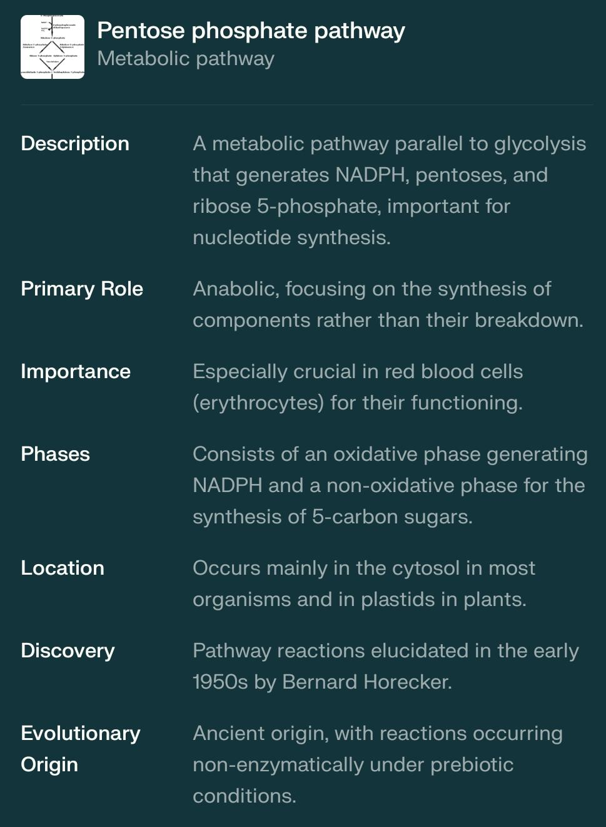

The pentose phosphate pathway is also referred to as a shunt pathway because it diverts glucose 6-phosphate from the main glycolytic pathway into a parallel metabolic route. This diversion of glucose 6-phosphate from glycolysis into the pentose phosphate pathway allows for the production of NADPH and pentoses, which are essential for various cellular processes such as nucleic acid synthesis and reductive biosynthesis reactions[1][2][3][4].

Here is a schematic representation of the pentose phosphate pathway, including the structures of substrates and products, as well as the names of enzymes involved in each step:

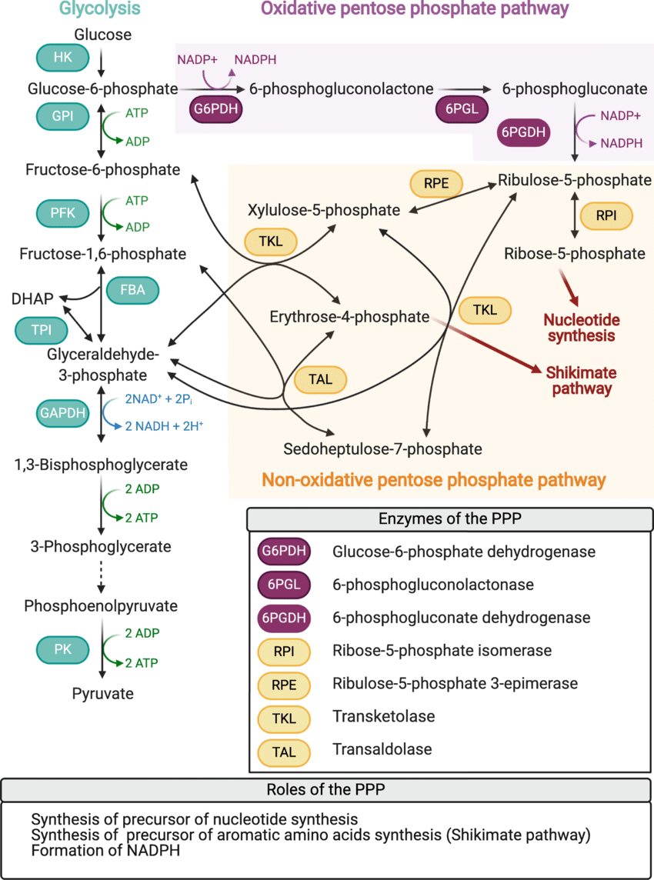

**Oxidative Phase:**

1. Glucose-6-phosphate (Glc6P) + NADP+ → 6-phosphoglucono-delta-lactone (6PGL) + NADPH

Enzyme: Glucose-6-phosphate dehydrogenase (G6PDH)

2. 6-phosphoglucono-delta-lactone (6PGL) → 6-phosphogluconate (6PG)

Enzyme: Gluconolactonase (6PGL)

3. 6-phosphogluconate (6PG) → Ribulose 5-phosphate (R5P) + CO2

Enzyme: 6-phosphogluconate dehydrogenase (6PGDH)

**Non-Oxidative Phase:**

1. Ribose 5-phosphate (R5P) → Xylulose 5-phosphate (X5P) + Glyceraldehyde 3-phosphate (G3P)

Enzyme: Transketolase (TKT)

2. Xylulose 5-phosphate (X5P) → Fructose 6-phosphate (F6P) + Glyceraldehyde 3-phosphate (G3P)

Enzyme: Transketolase (TKT)

3. Fructose 6-phosphate (F6P) → Glucose 6-phosphate (Glc6P) + Erythrose 4-phosphate (E4P)

Enzyme: Transaldolase (TALDO)

4. Ribose 5-phosphate (R5P) → Sedoheptulose 7-phosphate (S7P) + Glyceraldehyde 3-phosphate (G3P)

Enzyme: Transketolase (TKT)

5. Sedoheptulose 7-phosphate (S7P) → Fructose 6-phosphate (F6P) + Erythrose 4-phosphate (E4P)

Enzyme: Transketolase (TKT)

**Enzymes:**

- Glucose-6-phosphate dehydrogenase (G6PDH)

- Gluconolactonase (6PGL)

- 6-phosphogluconate dehydrogenase (6PGDH)

- Transketolase (TKT)

- Transaldolase (TALDO)

**Products:**

- NADPH

- Ribose 5-phosphate (R5P)

- Xylulose 5-phosphate (X5P)

- Glyceraldehyde 3-phosphate (G3P)

- Fructose 6-phosphate (F6P)

- Erythrose 4-phosphate (E4P)

- Sedoheptulose 7-phosphate (S7P)

This pathway plays a crucial role in maintaining the redox balance of the cell by generating NADPH, which is essential for various cellular processes. The pentose phosphate pathway also provides the building blocks for nucleic acid synthesis and reductive biosynthesis reactions[1][2][3][4].

* 1. ‘Crassulacean Acid Metabolism in an ecophysiological adaptation of desert plants.’ Justify the statement with biochemical details. How do CAM plants differ from C4 plants? 6+4

## Crassulacean Acid Metabolism (CAM): A Biochemical Adaptation for Desert Thriving (6 points)

CAM plants have evolved a unique photosynthetic pathway called Crassulacean Acid Metabolism, perfectly suited for the harsh realities of desert environments. Here's how the biochemistry of CAM allows them to thrive where others struggle:

1. **Water Conservation:** During the hot, dry desert days, CAM plants keep their stomata (tiny pores for gas exchange) closed. This minimizes water loss through transpiration, a major threat in arid conditions.
2. **Nighttime CO2 Fixation:** With stomata closed during the day, CAM plants open them at night, when temperatures are cooler and humidity is higher. This allows them to take in CO2, a crucial step in photosynthesis.
3. **Malic Acid Production:** The captured CO2 is then converted into a four-carbon organic acid, typically malate, by the enzyme phosphoenolpyruvate carboxylase (PEPC). This malate is stored in the plant's vacuoles overnight.
4. **Daytime CO2 Release and Fixation:** During the day, with stomata closed again, the stored malate is broken down by enzymes and released as CO2 within the cells. This CO2 then enters the Calvin Cycle, the core photosynthetic pathway, where it's fixed into sugars using the energy from sunlight captured by pigments like chlorophyll.

This separation of CO2 uptake (night) and CO2 fixation (day) is the key adaptation of CAM. It allows CAM plants to photosynthesize while minimizing water loss, a significant advantage in deserts.

## CAM vs. C4 Plants (4 points)

While both CAM and C4 plants are adaptations for hot, dry environments, they achieve water conservation through different biochemical pathways:

* **Timing of CO2 Fixation:** In CAM plants, CO2 fixation is separated into nighttime CO2 uptake and daytime fixation within the Calvin Cycle. C4 plants, however, fix CO2 into a four-carbon molecule (often oxaloacetate) during the day and then deliver it to the Calvin Cycle for sugar production, all within the same cell but at different locations.
* **Water Loss:** CAM plants excel at minimizing water loss by keeping stomata closed during the hot day. C4 plants can open their stomata partially during the day due to a mechanism that concentrates CO2 around the Calvin Cycle, reducing photorespiration (a wasteful process that releases CO2).

In essence, CAM plants prioritize extreme water conservation, while C4 plants achieve a balance between water use and maximizing CO2 fixation during the day.

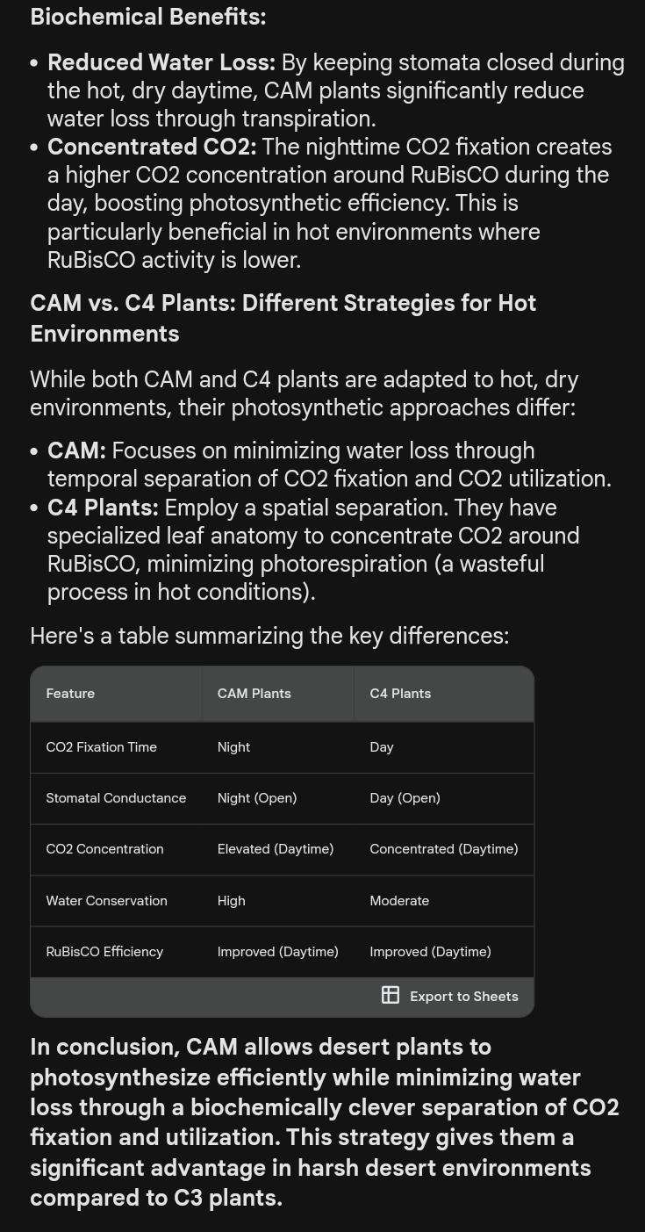

* 1. Discuss the role of Ca2+ as second messenger with reference to signal transduction pathway. 10

## Ca2+ as a Versatile Second Messenger in Signal Transduction (10 points)

Calcium (Ca2+) ions are ubiquitous second messengers within cells, playing a crucial role in translating extracellular signals into diverse cellular responses. Here's a breakdown of their function in the context of signal transduction pathways:

1. **Tightly Regulated Resting State (1 point):** For effective signaling, Ca2+ concentrations in the cytoplasm (cellular fluid) are maintained at very low levels during rest. This ensures a clear response when Ca2+ levels rise upon stimulation.
2. **Signal Reception and Mobilization (2 points):** Extracellular stimuli like hormones or neurotransmitters bind to specific receptors on the cell membrane. These receptors, often G-protein coupled receptors (GPCRs), trigger the release of Ca2+ from internal stores like the endoplasmic reticulum (ER). Additionally, Ca2+ influx from the extracellular space can occur through specific channels.
3. **Calmodulin Activation and Target Binding (2 points):** The rise in cytosolic Ca2+ activates a protein called calmodulin. This "calcium sensor" protein changes conformation upon binding Ca2+, becoming an activated "effector" molecule. Calmodulin then interacts with various downstream target proteins.
4. **Diverse Cellular Responses (2 points):** Depending on the cell type and specific target proteins involved, Ca2+ signaling can trigger a wide range of responses. Examples include:
   * **Muscle Contraction:** In muscle cells, Ca2+ binding to regulatory proteins initiates the contraction process.
   * **Neurotransmitter Release:** In neurons, Ca2+ influx stimulates the release of neurotransmitters for cell-to-cell communication.
   * **Gene Expression:** In some instances, Ca2+ signaling can activate pathways leading to changes in gene expression.
   * **Cell Division and Secretion:** Ca2+ plays a role in regulating cell division, secretion, and other cellular processes.
5. **Temporal and Spatial Control (1 point):** The duration and location of Ca2+ elevation are tightly controlled. Calcium pumps and exchangers actively restore Ca2+ to its resting state, ensuring a transient signal. Additionally, Ca2+ binding proteins can localize the signal to specific cellular compartments for targeted effects.
6. **Disruptions and Diseases (1 point):** Dysregulation of Ca2+ signaling pathways can contribute to various diseases. For example, abnormal Ca2+ handling is implicated in neurodegenerative disorders and heart failure.

In conclusion, Ca2+ serves as a versatile second messenger, enabling cells to translate a wide range of signals into specific and coordinated responses. Its tightly regulated dynamics and diverse downstream targets make it a crucial player in cellular communication and function.

## Ca2+ as a Versatile Second Messenger in Signal Transduction (10 points)

Calcium ions (Ca2+) are ubiquitous second messengers within cells, playing a critical role in translating extracellular signals into diverse cellular responses. Here's a breakdown of their key functions in signal transduction pathways:

1. **Tightly Regulated Resting State:** At rest, the cytosolic Ca2+ concentration is maintained at very low levels (around 100 nM) compared to the extracellular environment (around 1 mM). This creates a steep gradient for efficient Ca2+ influx when stimulated.
2. **Stimulus-Induced Mobilization:** Various external signals like hormones, neurotransmitters, or mechanical stimuli can trigger the release of Ca2+ from internal stores like the endoplasmic reticulum (ER). This happens through the activation of specific channels on the ER membrane. Additionally, Ca2+ can enter the cytosol directly from the extracellular space through plasma membrane channels.
3. **Signal Amplification:** A small initial stimulus can lead to a significant rise in cytosolic Ca2+ due to positive feedback mechanisms. For example, Ca2+ influx can activate further release of Ca2+ from the ER, amplifying the signal.
4. **Spatial and Temporal Control:** Ca2+ signals are not uniform throughout the cell. Localized release and specific Ca2+ binding proteins ensure the signal reaches the right target at the right time. This allows for highly specific cellular responses within different compartments.
5. **Interaction with Target Proteins:** Ca2+ binds to and activates various downstream effector proteins. A prominent example is calmodulin, which undergoes a conformational change upon Ca2+ binding. This "activated calmodulin" can then interact with other proteins like protein kinases or enzymes, triggering specific cellular processes.
6. **Diverse Cellular Responses:** Depending on the cell type and Ca2+ signal characteristics, Ca2+ can trigger a wide range of responses. Some examples include:
   * Muscle contraction
   * Neurotransmitter release
   * Gene expression changes
   * Cell division
   * Cell death
7. **Termination of the Signal:** To prevent prolonged activation, cells have mechanisms to return cytosolic Ca2+ levels to resting state. These include active Ca2+ pumping into the ER and extrusion of Ca2+ from the cell.

In conclusion, Ca2+ acts as a versatile second messenger due to its tightly controlled resting state, efficient mobilization mechanisms, and ability to interact with diverse target proteins. This allows for a wide range of cellular responses with precise spatial and temporal control within a cell. Understanding Ca2+ signalling is crucial for unraveling various physiological processes and diseases.

## Ca2+ as a Versatile Second Messenger in Signal Transduction (10 points)

Calcium ions (Ca2+) are ubiquitous second messengers within cells, playing a critical role in translating extracellular signals into diverse cellular responses. Here's a breakdown of their key functions in signal transduction pathways:

1. **Tightly Regulated Resting State:** At rest, the cytosolic Ca2+ concentration is maintained at very low levels (around 100 nM) compared to the extracellular environment (around 1 mM). This creates a steep gradient for efficient Ca2+ influx when stimulated.
2. **Stimulus-Induced Mobilisation:** Various external signals like hormones, neurotransmitters, or mechanical stimuli can trigger the release of Ca2+ from internal stores like the endoplasmic reticulum (ER). This happens through the activation of specific channels on the ER membrane. Additionally, Ca2+ can enter the cytosol directly from the extracellular space through plasma membrane channels.
3. **Signal Amplification:** A small initial stimulus can lead to a significant rise in cytosolic Ca2+ due to positive feedback mechanisms. For example, Ca2+ influx can activate further release of Ca2+ from the ER, amplifying the signal.
4. **Spatial and Temporal Control:** Ca2+ signals are not uniform throughout the cell. Localized release and specific Ca2+ binding proteins ensure the signal reaches the right target at the right time. This allows for highly specific cellular responses within different compartments.
5. **Interaction with Target Proteins:** Ca2+ binds to and activates various downstream effector proteins. A prominent example is calmodulin, which undergoes a conformational change upon Ca2+ binding. This "activated calmodulin" can then interact with other proteins like protein kinases or enzymes, triggering specific cellular processes.
6. **Diverse Cellular Responses:** Depending on the cell type and Ca2+ signal characteristics, Ca2+ can trigger a wide range of responses. Some examples include:
   * Muscle contraction
   * Neurotransmitter release
   * Gene expression changes
   * Cell division
   * Cell death
7. **Termination of the Signal:** To prevent prolonged activation, cells have mechanisms to return cytosolic Ca2+ levels to resting state. These include active Ca2+ pumping into the ER and extrusion of Ca2+ from the cell.

In conclusion, Ca2+ acts as a versatile second messenger due to its tightly controlled resting state, efficient mobilization mechanisms, and ability to interact with diverse target proteins. This allows for a wide range of cellular responses with precise spatial and temporal control within a cell. Understanding Ca2+ signaling is crucial for unraveling various physiological processes and diseases.

* 1. Write down the biochemical reactions of β oxidation of fatty acids. Mention the stoichiometry of ATP production after complete oxidation of palmitic acid (C = 16). 6+4

## Biochemical Reactions of β-Oxidation and ATP Stoichiometry (10 points)

**β-Oxidation Pathway:**

β-oxidation is a metabolic pathway that breaks down fatty acids into acetyl-CoA units, a precursor molecule for energy production in the citric acid cycle. Here's a breakdown of the key reactions involved:

1. **Activation:** Fatty acids with long chains are first activated in the cytosol by attaching Coenzyme A (CoA) with the help of the enzyme fatty acyl-CoA synthetase. This reaction consumes ATP.

**Fatty acyl-CoA + ATP + CoA --> Acyl-CoA thioester + AMP + PPi**

1. **Dehydrogenation (x cycles):** The activated fatty acyl-CoA is then transported into the mitochondrial matrix where the core β-oxidation cycle occurs. Each cycle involves four main steps:
2. a. The first carbon (α-carbon) of the fatty acyl-CoA is dehydrogenated by acyl-CoA dehydrogenase, producing an enoyl-CoA and FADH2.
3. **Acyl-CoA (Cn) + FAD --> Enoyl-CoA (Cn-2) + FADH2**
4. **Hydration:** A double bond is introduced into the enoyl-CoA by enoyl-CoA hydratase, forming L-3-hydroxyacyl-CoA.
5. **Enoyl-CoA (Cn-2) + H2O --> L-3-Hydroxyacyl-CoA (Cn-2)**
6. **Dehydrogenation:** L-3-hydroxyacyl-CoA is further dehydrogenated by L-3-hydroxyacyl-CoA dehydrogenase, generating ketoacyl-CoA and NADH.
7. **L-3-Hydroxyacyl-CoA (Cn-2) + NAD+ --> Ketoacyl-CoA (Cn-2) + NADH + H+**
8. **Thiolysis:** The ketoacyl-CoA is cleaved by ketoacyl-CoA thiolase, releasing one molecule of acetyl-CoA and a new fatty acyl-CoA with two fewer carbon atoms. This shorter fatty acyl-CoA can then re-enter the cycle for further breakdown.
9. **Ketoacyl-CoA (Cn) + CoA-SH --> Acetyl-CoA + Acyl-CoA (Cn-2)**

**Number of Cycles for Palmitic Acid:**

Palmitic acid (C16) has 16 carbon atoms. Each β-oxidation cycle shortens the fatty acyl-CoA by two carbons. Therefore, complete oxidation of palmitic acid requires 7 rounds of the β-oxidation cycle (16 carbons / 2 carbons/cycle = 7 cycles).

**ATP Stoichiometry:**

β-oxidation itself doesn't directly generate ATP. However, the generated NADH and FADH2 molecules enter the electron transport chain in the mitochondria, which ultimately produces ATP.

* Each cycle produces 1 FADH2 and 1 NADH.
* In the electron transport chain, 1 NADH produces approximately 3 ATP molecules.
* 1 FADH2 produces about 2 ATP molecules.

Therefore, for the complete oxidation of palmitic acid (7 cycles):

* Total NADH produced = 7 cycles/cycle * 1 NADH/cycle = 7 NADH
* Total FADH2 produced = 7 cycles/cycle * 1 FADH2/cycle = 7 FADH2
* ATP from NADH = 7 NADH * 3 ATP/NADH = 21 ATP
* ATP from FADH2 = 7 FADH2 * 2 ATP/FADH2 = 14 ATP
* Total ATP produced = 21 ATP + 14 ATP = 35 ATP

**Overall, the complete oxidation of palmitic acid (C16) through β-oxidation generates 35 ATP molecules.**

* 1. Describe the biochemistry of Nitrogen fixation with special reference to the role of Nitrogenase and leg-haemoglo on. 6+4

Nitrogen fixation is a fundamental biological process that converts atmospheric nitrogen (N2) into ammonia (NH3) or other nitrogen compounds usable by living organisms. This process is essential because atmospheric nitrogen, though abundant, is in a form that most organisms cannot directly utilize. Certain bacteria and archaea possess the unique ability to perform nitrogen fixation, employing specialized enzymes and proteins to carry out this conversion.

### Biochemistry of Nitrogen Fixation

#### Nitrogenase Enzyme

**1. Structure and Components:**

- **Fe Protein and MoFe Protein:** Nitrogenase consists of two main protein components: the iron protein (Fe protein) and the molybdenum-iron protein (MoFe protein).

- **Fe Protein:** Acts as an electron carrier, transferring electrons from a high-energy donor molecule (typically ATP) to the MoFe protein.

- **MoFe Protein:** Contains the active site where the actual nitrogen fixation occurs. It contains iron (Fe), molybdenum (Mo), and sulfur (S) atoms in its cofactors, crucial for its catalytic activity.

**2. Mechanism of Nitrogen Fixation:**

- **Electron Transfer:** The Fe protein transfers electrons to the MoFe protein, which then initiates the reduction of N2.

- **Reduction Steps:** The MoFe protein reduces N2 to ammonia (NH3) through a series of electron transfers and protonation steps:

- **Binding and Activation of N2:** N2 binds to the MoFe protein, where it is activated and prepared for reduction.

- **Sequential Reduction:** Multiple electron transfers from Fe protein to MoFe protein lead to the stepwise reduction of N2 to NH3.

- **Protonation:** Protons (H+) are added to nitrogen atoms to form NH3, which can be further utilized by the organism.

**3. Energy Requirements:**

- **ATP Consumption:** Nitrogen fixation by nitrogenase is an energy-intensive process, requiring ATP as an energy source to drive the electron transfer reactions necessary for N2 reduction.

#### Role of Leg-Hemoglobin

Leg-hemoglobin is a specialized protein found in the root nodules of leguminous plants that form symbiotic relationships with nitrogen-fixing bacteria (e.g., Rhizobium species).

**1. Function:**

- **Oxygen Regulation:** Leg-hemoglobin plays a crucial role in maintaining a low-oxygen environment within the root nodules, where nitrogen fixation occurs.

- **Oxygen Binding:** Similar to other hemoglobins, leg-hemoglobin binds oxygen tightly, preventing its accumulation and ensuring that oxygen concentrations remain low enough to prevent inhibition of nitrogenase activity.

- **Protection of Nitrogenase:** Oxygen is known to irreversibly inhibit nitrogenase enzymes. Leg-hemoglobin's ability to sequester oxygen protects nitrogenase from this inhibition, thereby maintaining efficient nitrogen fixation.

**2. Structural Adaptations:**

- **Oxygen Affinity:** Leg-hemoglobin has a high affinity for oxygen, allowing it to effectively scavenge oxygen within the nodule environment.

- **Iron Binding:** Like other hemoglobins, leg-hemoglobin contains iron atoms in its structure, which bind to oxygen molecules, preventing them from interfering with nitrogenase.

### Overall Process in Legume-Rhizobium Symbiosis

In leguminous plants:

- **Symbiotic Relationship:** Rhizobium bacteria colonize the roots and form nodules, where they establish a symbiotic relationship with the host plant.

- **Nitrogen Fixation:** Within these nodules, nitrogen-fixing bacteria utilize nitrogenase enzymes to convert atmospheric nitrogen to ammonia.

- **Role of Leg-Hemoglobin:** Leg-hemoglobin is crucial for creating an oxygen-depleted environment necessary for efficient nitrogen fixation by binding oxygen and ensuring it does not inhibit nitrogenase activity.

In summary, nitrogen fixation involves complex biochemical processes centered around nitrogenase enzymes, which catalyze the conversion of atmospheric nitrogen to ammonia. Leg-hemoglobin in leguminous plants plays a vital role by maintaining low oxygen levels within root nodules, thereby protecting nitrogenase and ensuring effective nitrogen fixation. This symbiotic relationship between plants and nitrogen-fixing bacteria is essential for maintaining soil fertility and supporting plant growth in diverse ecosystems.

OR//

Certainly! Let’s delve into the fascinating world of nitrogen fixation. 🌱

1. **Enzymology of Nitrogen Fixation:**
   * Nitrogen fixation is the process by which atmospheric nitrogen (

N_2N2​

) is converted into ammonia (

NH_3NH3​

), a form that plants can use.

* + The key enzyme complex responsible for this conversion is **nitrogenase**.
  + Nitrogenase consists of two components:
    - **Dinitrogenase (MoFe-protein)**: A 240-kDa heterotetramer that binds

N_2N2​

and facilitates its reduction to ammonia. It holds

N_2N2​

during the reduction process.

* + - **Dinitrogenase reductase (Fe-protein)**: A 64-kDa homodimer that provides high-energy electrons to di-nitrogenase. It is extremely sensitive to oxygen.
  + The **Fe-protein** contains identical subunits and has a Fe

_44​

S

_44​

cluster. Its role is to supply electrons to di-nitrogenase.

* + The **MoFe-protein** contains two pairs of metal clusters:
    - **P-clusters**: These 8Fe-7S iron-sulfur complexes serve as catalytic centers. In their reduced state (P

_NN​

), they resemble two distorted 4Fe-4S cubes.

* + - **MoFe cofactor (MoFeCo)**: A large redox center with Fe

_44​

S

_33​

and Fe

_33​

MoS

_33​

, where homocitrate, linked to molybdenum, is also part of this cofactor.

* + **Hydrogenase**, another enzyme, activates molecular hydrogen. It’s distinct from nitrogenase and is involved in H

_22​

evolution.

1. **Role of Leghemoglobin (Leg Hb):**
   * Leguminous plants form a symbiotic association with nitrogen-fixing bacteria (e.g., Rhizobium) in root nodules.
   * These bacteria, called **bacteroids**, fix nitrogen.
   * Leghemoglobin (Leg Hb) is produced in the roots of legumes and acts as an oxygen scavenger.
   * Leg Hb creates an **anaerobic environment** around nitrogenase, allowing it to function optimally.
   * Leg Hb removes oxygen, protecting nitrogenase from its inhibitory effects.

In summary, nitrogen fixation involves intricate enzymatic processes, with nitrogenase at its core, and leg-hemoglobin plays a crucial role in maintaining the right conditions for nitrogenase activity. 🌿🔬

**Please Turn Over**